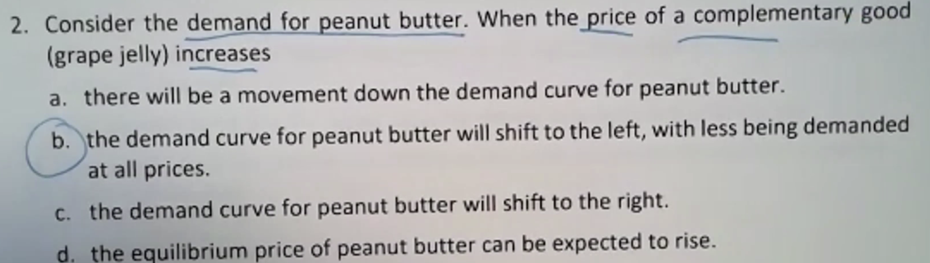

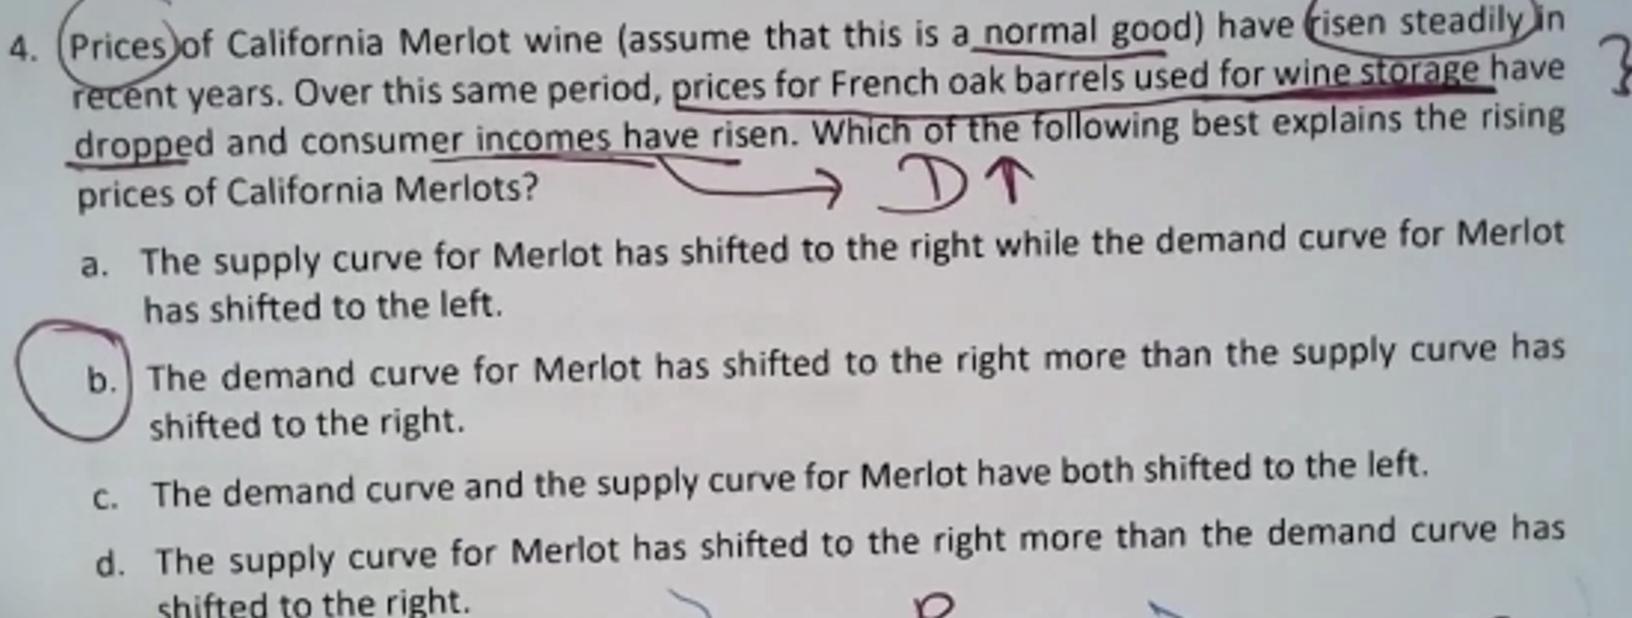

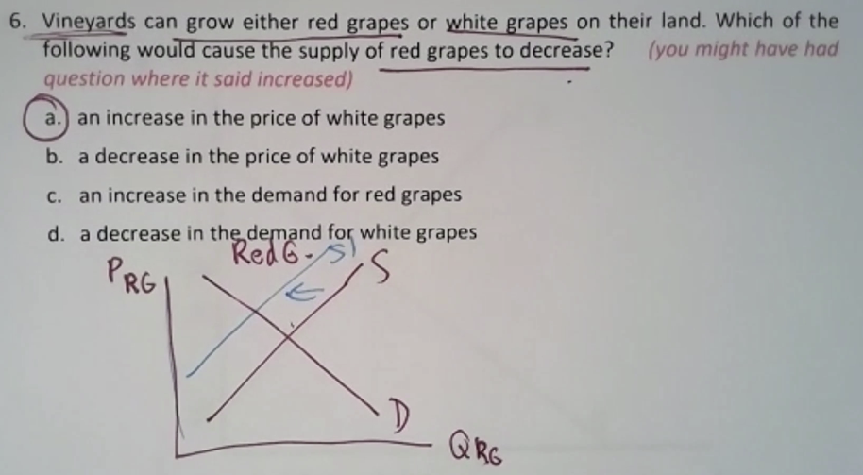

Outline:

* The Price Elasticity of Demand and Its Measurement
* The Determinants of the Price Elasticity of Demand
* The Relationship between the Price Elasticity of Demand and Total Revenue

Price Elasticity of Demand

* Elasticity: *Percentage change in one variable resulting from a 1-percent increase in another.*
* Price Elasticity of Demand: *Percentage change in quantity demanded of a good resulting from a 1-percent increase in its price.*

**Determinants of Income Elasticity**

Income elasticities also differ from the short run to the long run.

* For most goods and services—foods, beverages, fuel, entertainment, etc.— the income elasticity of demand is larger in the long run than in the short run.
* For a durable good, the opposite is true. The short-run income elasticity of demand will be much larger than the long-run elasticity.

Chapter 11

Outline

* Production Technology
* Short Run vs. Long Run
* Measuring Cost: Which Costs Matter?
* Cost in the Short Run vs. Long Run
* Economies of Scale

